*Core*

*d3*

*D*

*d2*

*d1*

*d3*

*D*

*Core*

*d2*

*d1*

*dc*

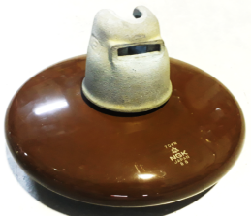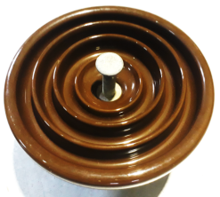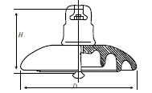

Porcelain

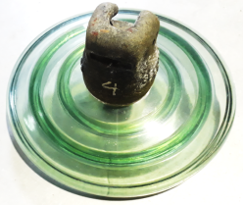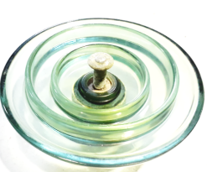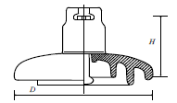

Glass

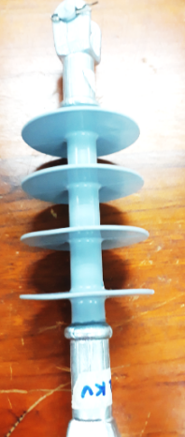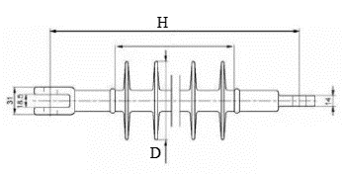

SIR

**Figure 1.** Insulators samples.

*d3*

*d1*

*d2*

*dc*

*dc*

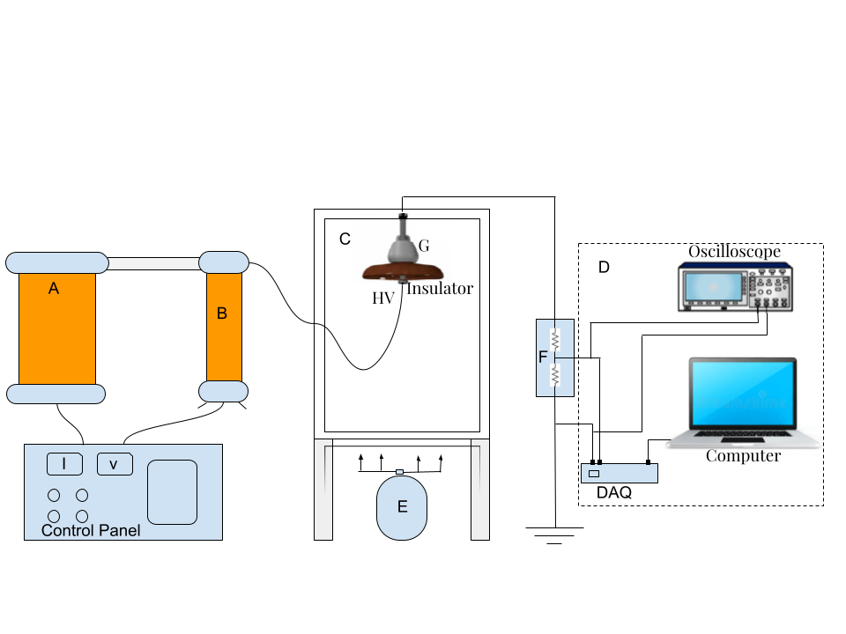

(a)

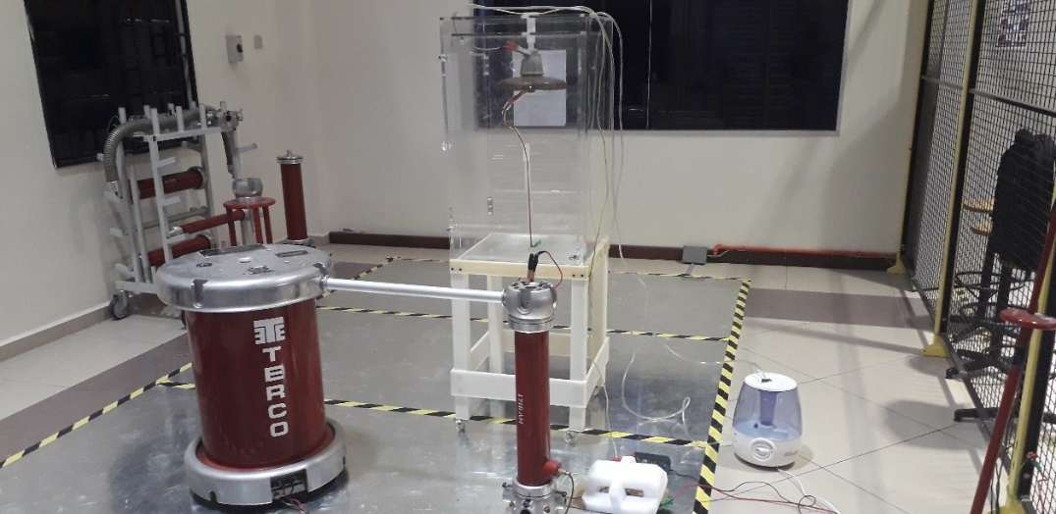

A

B

C

E

F

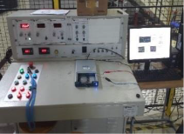

(b)

**Figure 2.** Insulator Test: (a) Experiment setup Schematic diagram; (b) Test pictorial view.



**Figure 3.** Leakage current monitoring process.



**Figure 4.** Flowchart process of insulator condition diagnosis.



**Figure 5.** The phase difference between leakage current and applied voltage.

 

(a) (b)

**Figure 6.** Extracting leakage current characteristics:(a) slope curve, (b) crest factor.

 

(a)

 

(b)

 

(c)

 

(d)

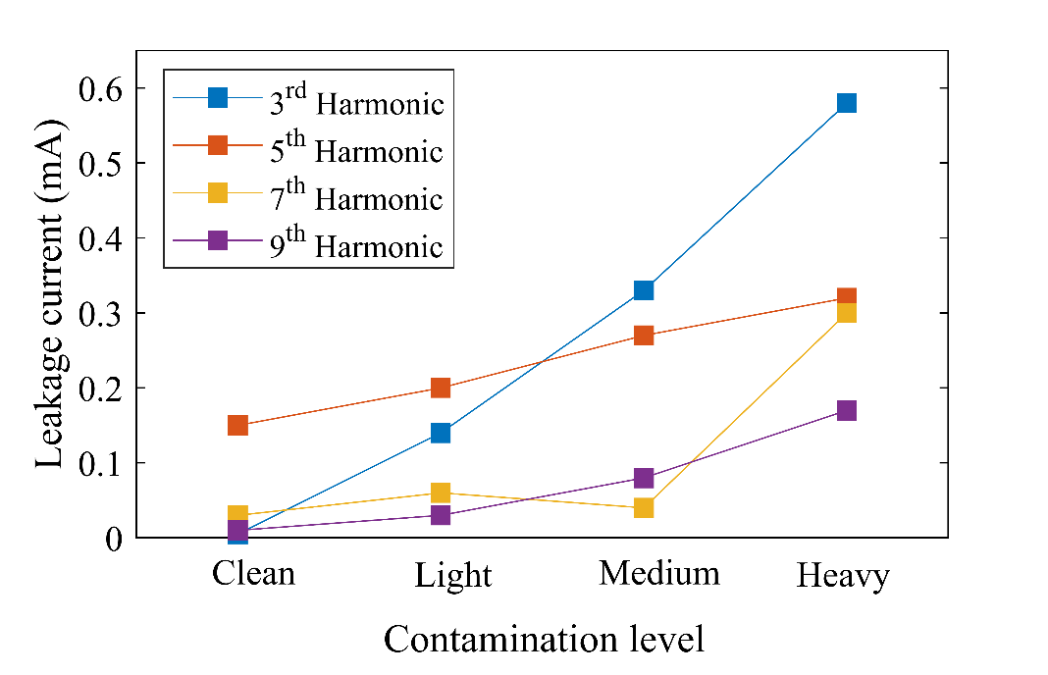**Figure 7.** LC waveform and its FFT under different SDD pollution degree, 0.15 of NSDD, and 3 l/h of wetting rate: (**a**) SDD=0.00 mg/cm2; (**b**) SDD=0.05 mg/cm2, (**c**) SDD=0.12 mg/cm2, (**d**) SDD=0.2 mg/cm2.

**Figure 8.** Odd harmonics of leakage current under pollution grading



(a) (b)

Figure 9. Flashover voltage of glass insulator vs. (a) SDD and NSDD (b) SDD and Wt under different non-uniformity degrees Pu/PL

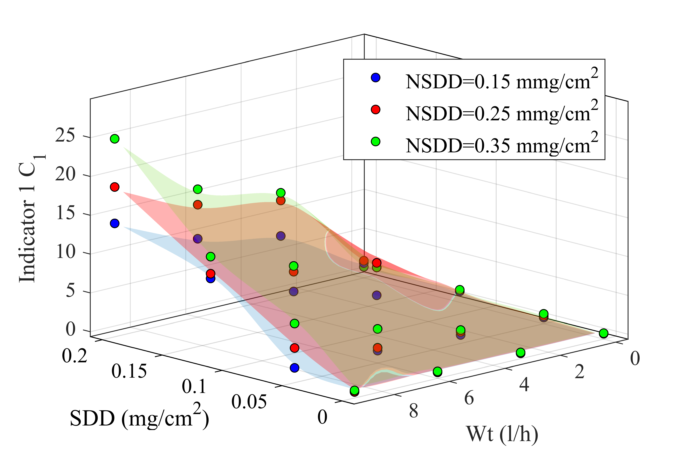 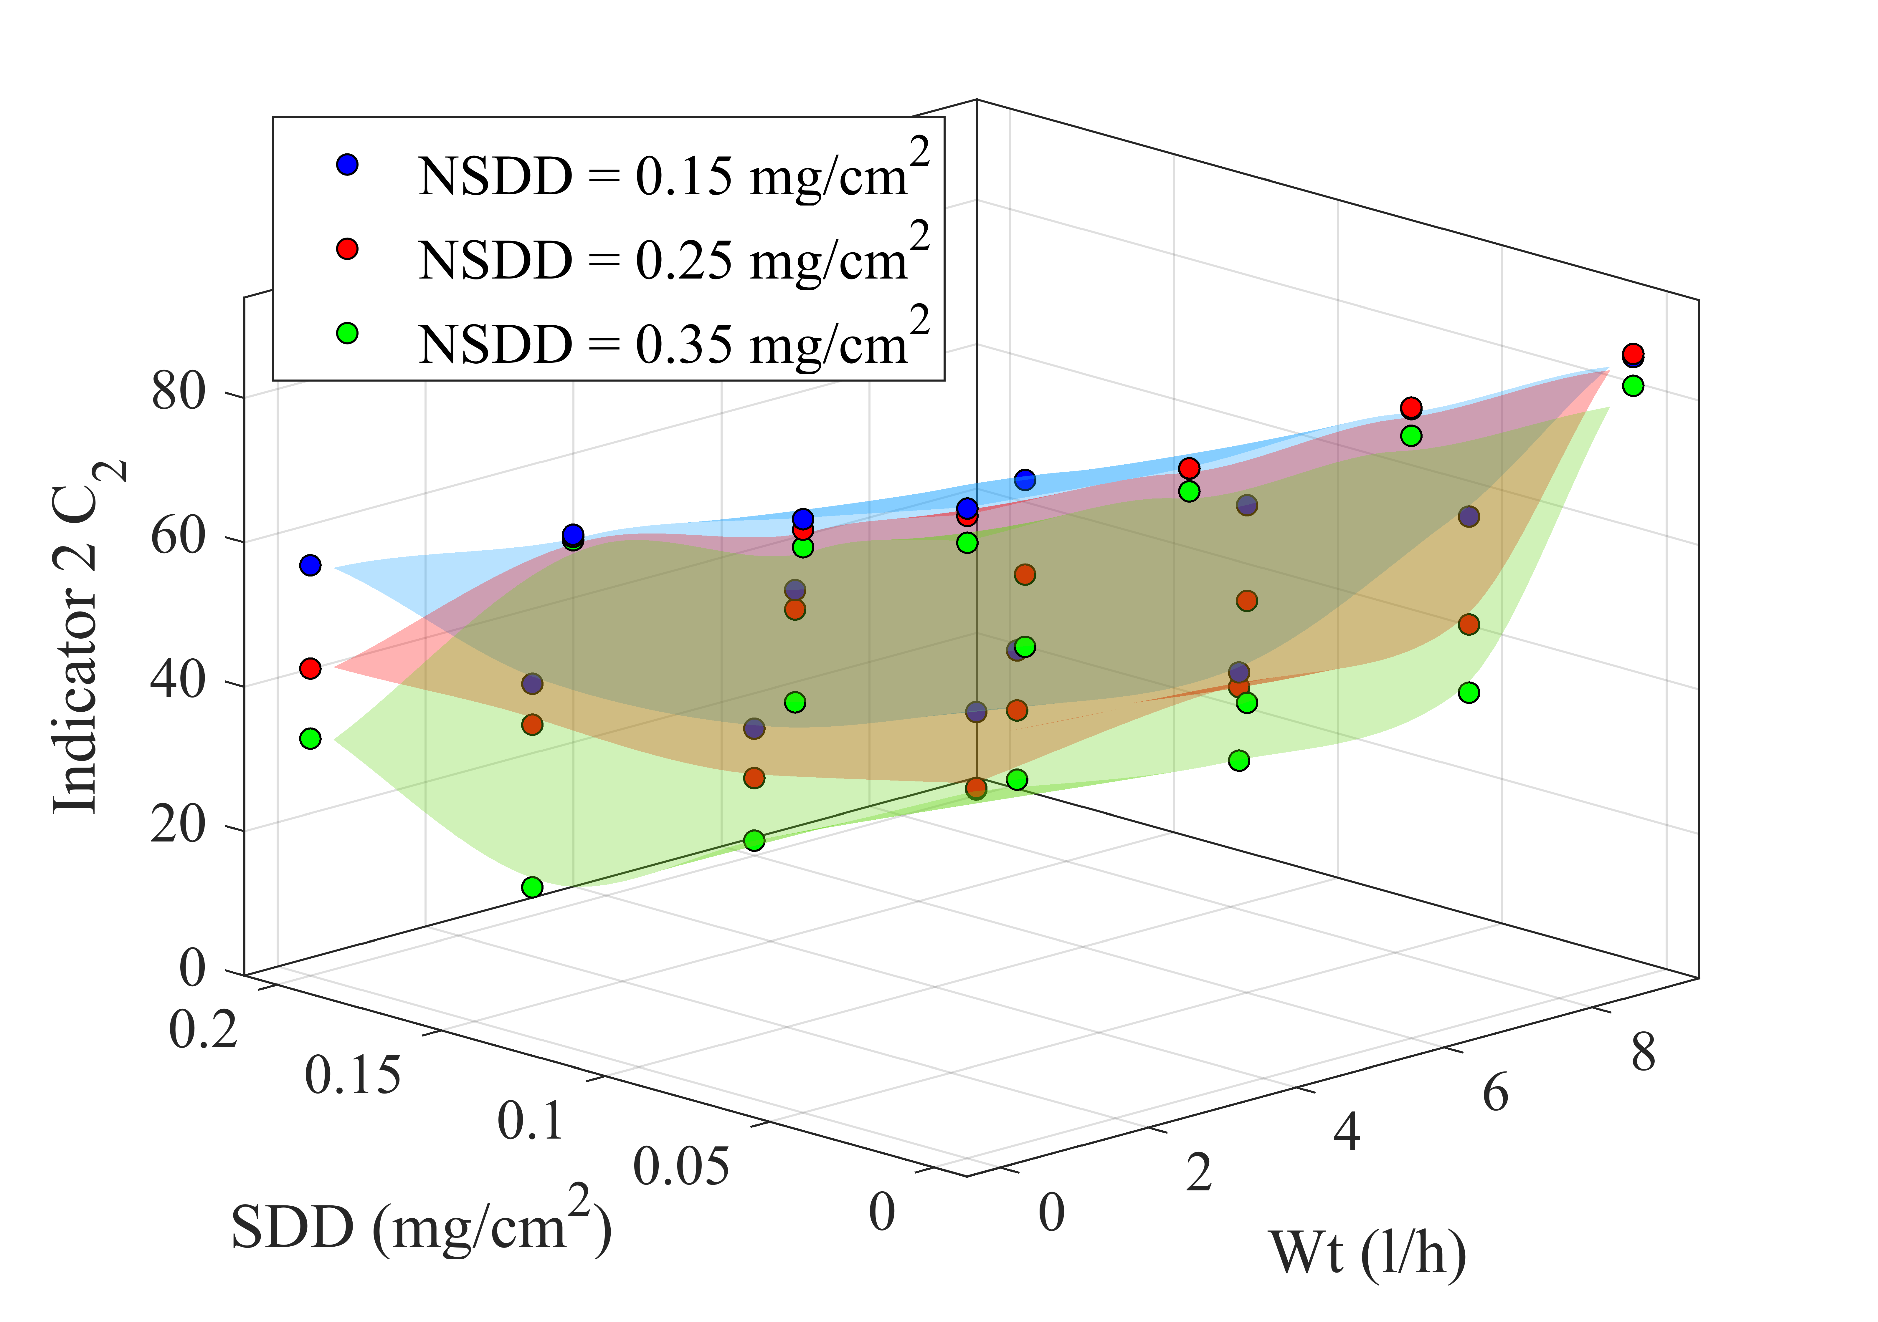

(a) (b)

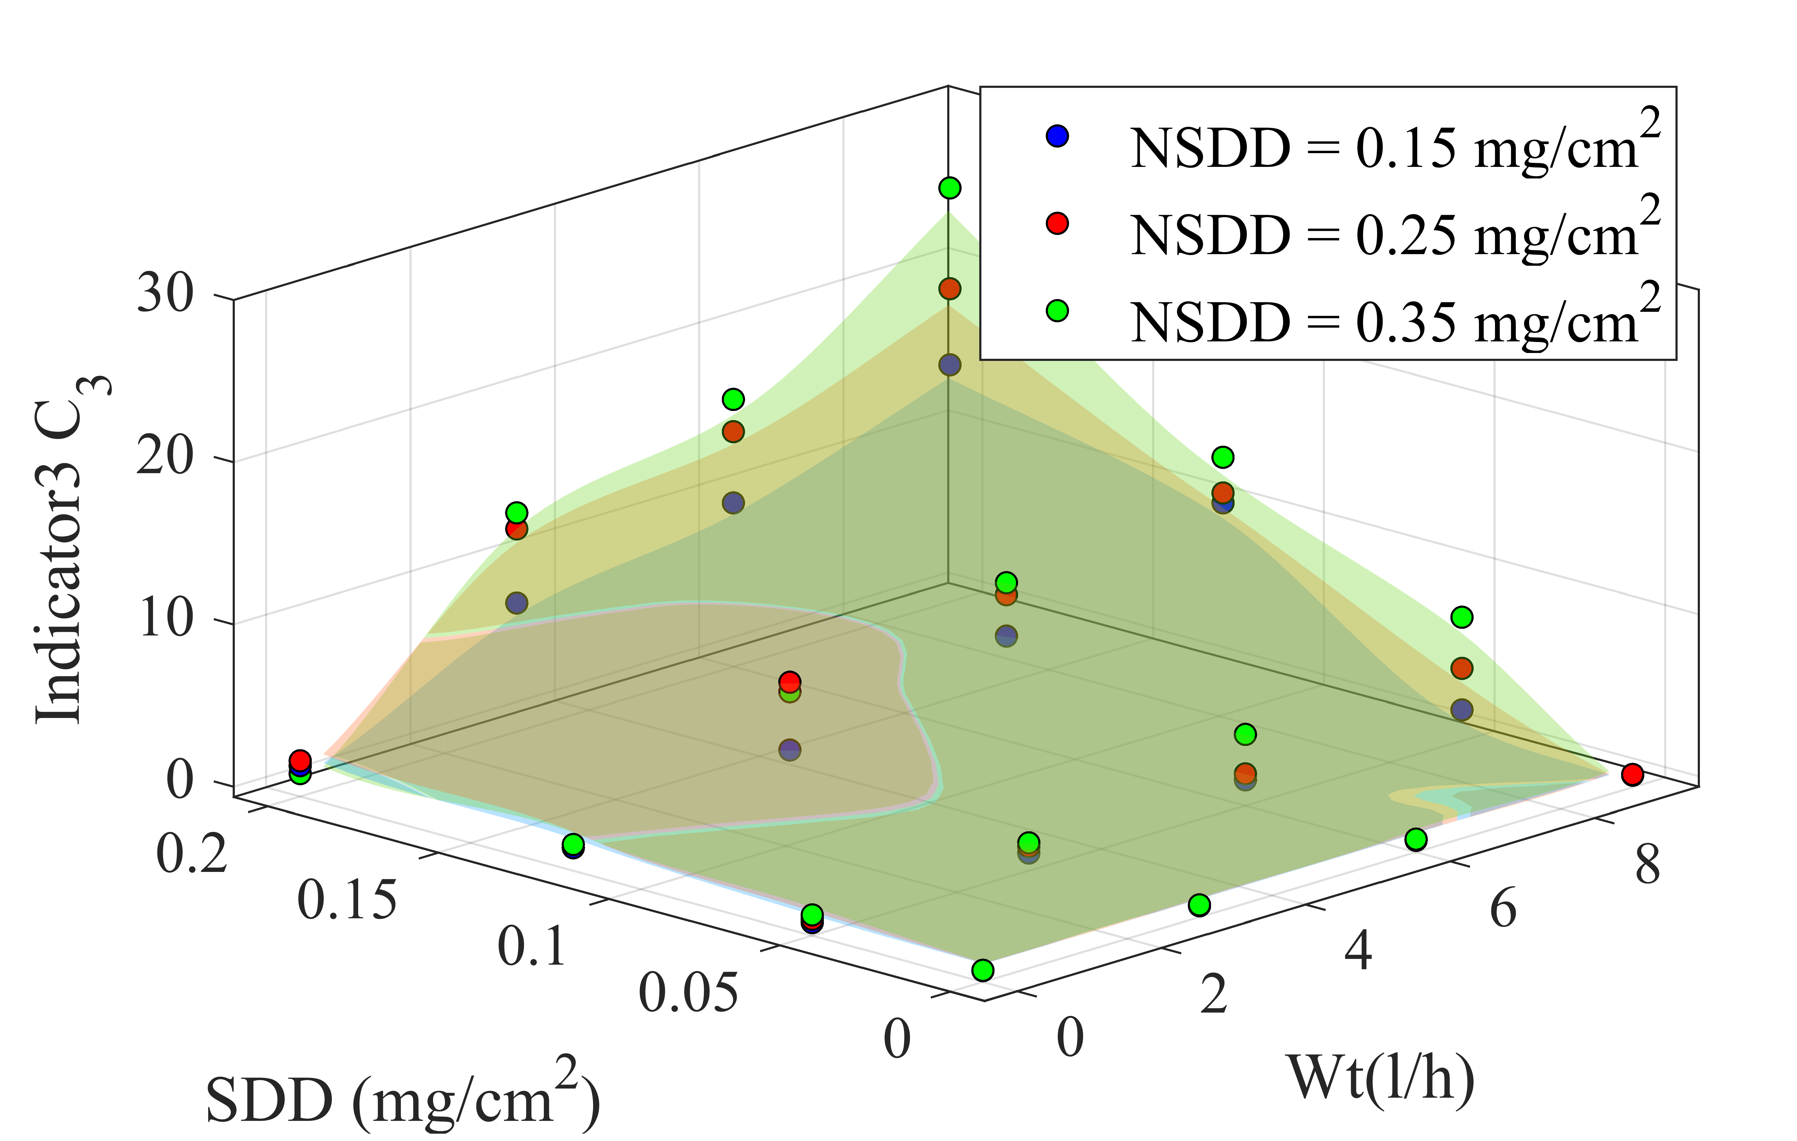 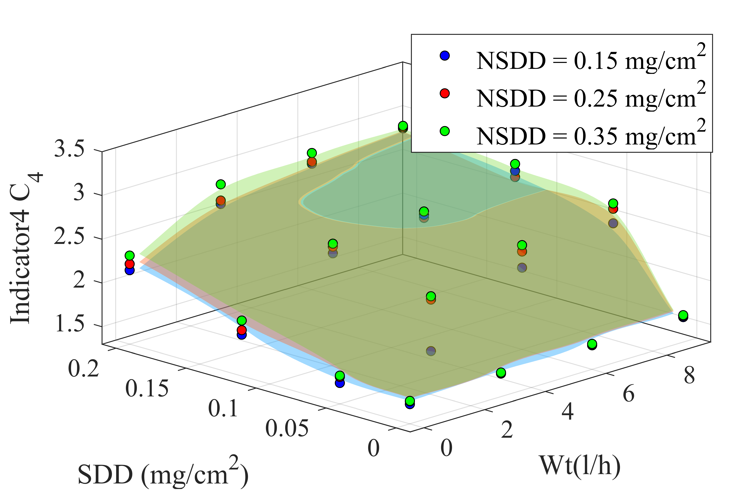

(c) (d)

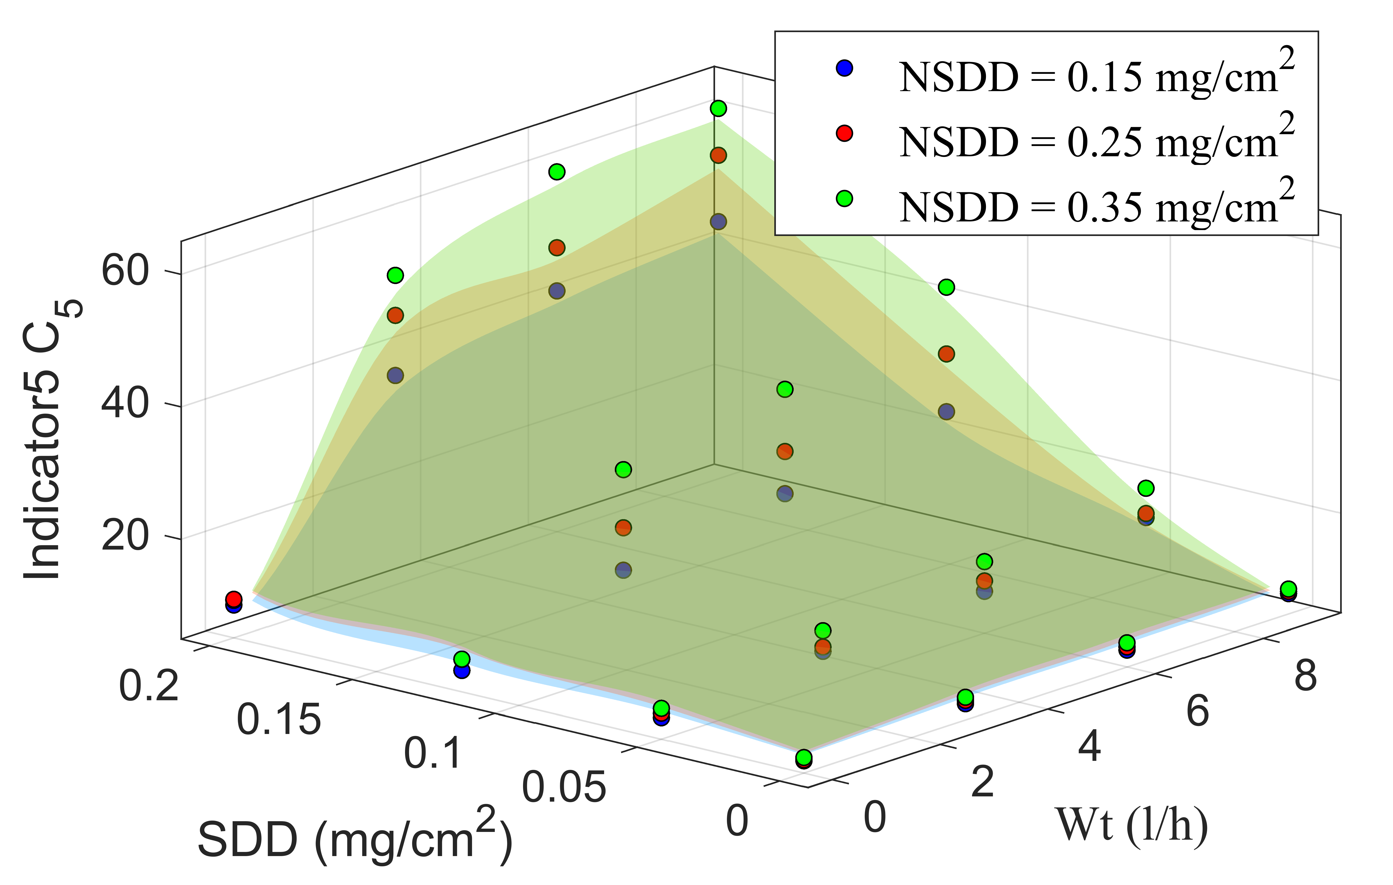 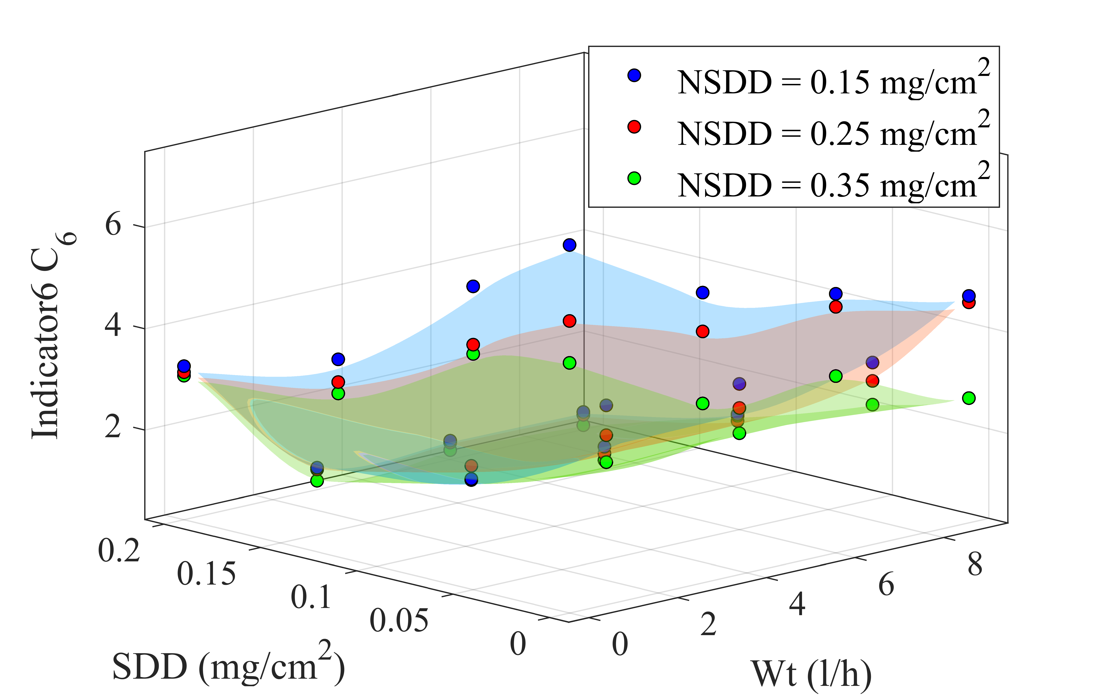

(e) (f)

**Figure 10.** Leakage current indicators of uniform polluted insulators under various Wt and NSDD: (**a**) C1; (**b**) C2; (c) C3; (d) C4; (e) C5; (f) C6.



(b)

(a)



(c)

(d)



(f)

(e)

**Figure 11.** LC indicators versus NSDD for tested insulators under SDD=0.2 mg/cm2, Wt=9l/h and Pu/PL =1/1: (**a**) C1; (**b**) C2; (c) C3; (d) C4; (e) C5; (f) C6.



(b)

(a)



(d)

(c)

 

(f)

(e)

**Figure 12.** LC indicators versus Wt for tested insulators under SDD=0.2 mg/cm2, NSDD= 0.35 mg/cm2 and Pu/PL=1/1: (**a**) C1; (**b**) C2; (c) C3; (d) C4; (e) C5; (f) C6.



(b)

(a)



(d)

(c)



(e)

(f)

**Figure 13.** LC indicators versus Pu/PL for tested insulators under SDD=0.2 mg/cm2, NSDD= 0.35 mg/cm2 and Wt=9 l/h: (**a**) C1; (**b**) C2; (c) C3; (d) C4; (e) C5; (f) C6.

 

(a) (b)



**Figure 14.** Flashover voltage indicator under different: (a) SDD; (b) NSDD; (c) Wt; (d) Pu/PL



**Figure 15.** Confusion matrix for determining indices' sensitivity, specificity, and accuracy.



**Figure 16.** The indicators sensitivity, specificity, accuracy, and the difference between sensitivity and specificity.

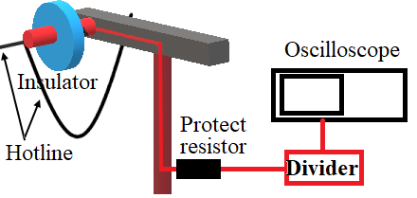

Test line

Figure 17. Test insulators on the site